Jerzy O. Szablowski, Ph.D.
6500 Main St.
BRC 869, MS 142
Houston, TX 77006
szablowskilab.org
Work: (713)-348-8738 js170@rice.edu
EDUCATION
2015-19 California Institute of Technology (Caltech)
Postdoctoral fellowship, Department of Chemical Engineering
Acoustically Targeted Chemogenetics (ATAC) for noninvasive control of brain circuitry
Advisor: Mikhail G. Shapiro
2009-15 California Institute of Technology (Caltech)
Ph.D. in Bioengineering, Field: Chemical Biology
Biological Activity of Pyrrole-Imidazole polyamide in vivo
Advisor: Peter B. Dervan
2005-09 Massachusetts Institute of Technology (MIT)
B.Sc. in Biological Engineering, minor in Biology

PROFESSIONAL EXPERIENCE
2025 Episteme Inc., scientific advisor, San Francisco, CA

2024- Imprint Bio, Co-founder and CEO, Houston, TX

2020- Rice University, Assistant Professor, Bioengineering, and Rice Neuroengineering Initiative (RNI) core member

2015-19 Caltech, Shapiro Lab, Postdoctoral, Chemical Engineering

2010-15 Caltech, Dervan lab, Graduate Research Assistant, Bioengineering

2007-09 MIT, Synthetic Neurobiology Group (Pi: Edward Boyden; MIT Media Lab), Undergrad- uate Research Assistant

2005-07 MIT, Robert Langer and Alan Jasanoff labs; Caltech, Frances Arnold lab, Undergrad- uate Research Assistant

AWARDS AND HONORS

Selected awards

2025 Bright Focus Foundation, Dr. Joe G. Hollyfield New Investigator Award for Macular Degeneration Research
2023 NIH Director’s New Innovator Award (DP2)
2022 NIH NIBIB Trailblazer Award
2022 DARPA Young Faculty Award
2021 Packard Fellowship for Science and Engineering
2020 Outstanding Undergraduate Research Mentor Award, Rice University
2018 NARSAD Young Investigator, Brain and Behavior Research Foundation
2009 Henry and Grazyna Bauer Fellowship for graduate studies

Other awards

2024 Career Champion, Rice University
2023 Career Champion, Rice University
2019 Focused Ultrasound foundation, 2nd prize poster, FUS Neuromodulation Symposium 2019, University of Oxford
2018 World Molecular Imaging Congress travel award
2009 International Genetic Engineering Machines competition (iGEM), 3rd place worldwide, (Synthetic Standard prize), Best New Application area and Best Experimental Measurement awards.
2008 BE-BMES/Johnson&Johnson Prize for Excellence in Biomedical Research
2002 Finalist of Physics Olympiad for Secondary School students (Poland)

Selected Trainee awards
NSF GRFP (x3), NDSEG, and NSF NRT fellowships (x2), Goldwater scholarships (x2), BRAIN initiative trainee highlight awards (x2), JSPS postdoctoral fellowship, Knight-Hennessy fellowship, PhRMA foundation starter research grant, Sigma Xi aid in research grant, Outstanding PhD Thesis Award, Rice University Bioengineering (2025)
TEACHING EXPERIENCE
2025 Guest lecturer, ELEC 518, Principles of Biomedical Optics and Ultrasound, Rice University, Hou ston, TX, F25
2020-current Lecturer, BioE 422 / 522: Gene therapy, Rice University, Houston, TX
(Teaching evaluations, overall effectiveness: 1.3/5.0 with 1 being maximum, and 5 minimum, n =9 semesters taught; Total enrollment to date: 54 undergraduates, 78 Master’s and Ph.D. students)

2022 Guest Lecturer, ELEC 682 Spotlight on Latest Neurotechnology, Rice University, Houston, TX
2021 Guest Lecturer, BME 6470-001 Studies in Neural Engineering, University of Utah, Salt Lake City, UT
2019 Lecturer, Bi 23: Current Advances in Gene Therapy, Caltech, Pasadena, CA

PUBLICATIONS (selected)
‘#’ denotes equal contribution, first author contributions underlined; * corresponding author; # co-first author; For most recent updates visit: https://www.szablowskilab.org/publications
At Rice [Since 2020: 17 published, preprints, in review, and in revision; 12 corresponding, 4 co-corresponding, 1 contributing]
- Lu J, Lee S, Wang M , Zheng K , Oh SH, Lee J, Soh S , Cao Y , Bao X , Nouraein S , Szablowski JO*, Chen R*, Monitoring Gene Expression in Retina with synthetic serum markers, bioRxiv (2026): 2026-01
- Link S, Fan K, Adame J, Keen C, Frankfort BJ*, Szablowski JO*, Ultrasound-enhanced retinal delivery of engineered viral vectors, bioRxiv 2026.01.04.697446, in review, IOVS
- Buitrago NS, Brau J, Szablowski JO*, Modeling synthetic serum markers kinetics for monitoring deep-tissue gene expression, bioRxiv 2025.11.17.688787, (2025), in review, PLOS Comp. Bio.
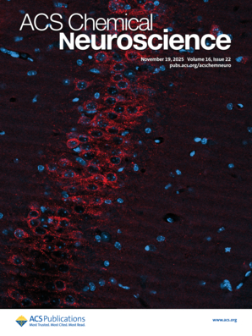
- Lee S#, Mckenna S#, Watanabe S, Chernov M, Li H, Raisley EK, Szablowski JO*, Costa V*, Synthetic Serum Markers Enable Noninvasive Monitoring of Gene Expression in Primate Brains, bioRxiv 2025.06.01.657212, (2025), Neuron, in press
- Li H, Nourain S, Lee S, Link S, Raisley EK, Szablowski JO*, Noninvasive Control of Seizure Threshold with Acoustically Targeted Chemogenetics, ACS Chemical Neuroscience (2025), 16, 22, 4327–4340,
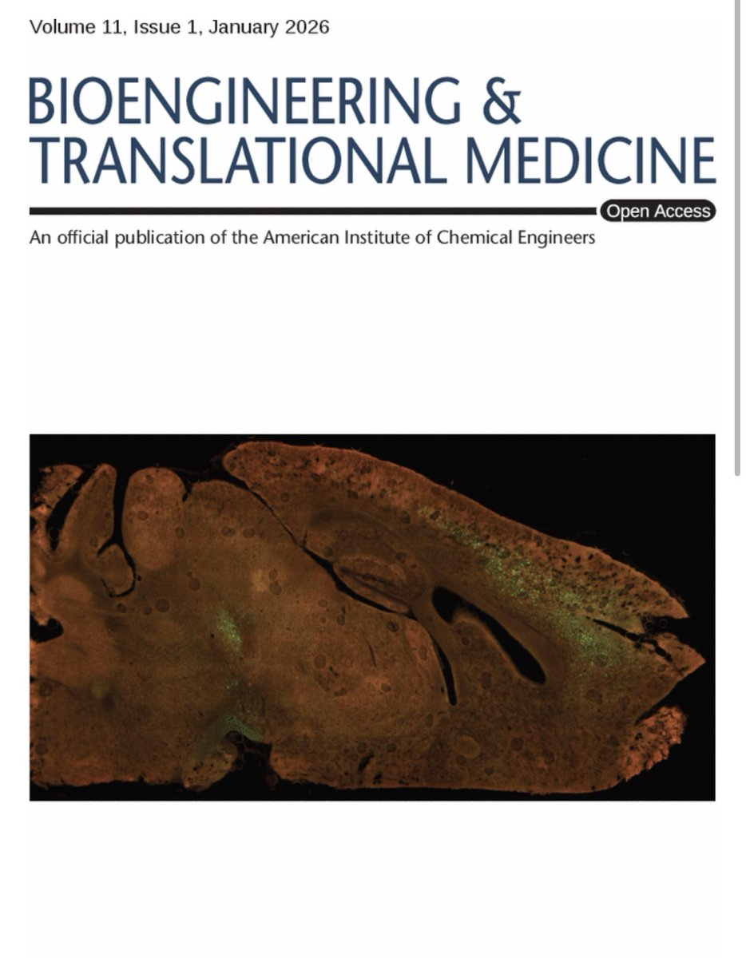
- Nouraein S, Lee S, Li H, Saenz V, Raisley EK, Costa VD, Szablowski JO*. Erasable Synthetic Serum Markers. PNAS, (2025) 122 (49) e2511741122,
- Harb M, Nouraein S, Szablowski JO*, Site-Specific Noninvasive Delivery of Retrograde Viral Vectors to the Brain, AiChE Bioeng Transl Med. 2026; 11(1):e70062. doi:10.1002/btm2.70062
- Watanabe S, Lee S, Harb M, Nouraein S, Raisley E, Li H, Buitrago N, Pforr B, Szablowski JO*, Monitoring in vivo transcription with synthetic serum markers, bioRxiv 2024.12.10.627810, (2024), Nature Communications, in 2nd revision
- Seo JP, Trippett JS, Lee S, Huang Z, Nouraein S, Wang R, Szablowski JO*. Acoustically-Targeted Measurement of Transgene Expression in the Brain, Science Advances, 10, eadj7686, Science Advances (2024)
- Li HR, Harb M, Heath JE, Trippett JS, Shapiro MG*, Szablowski JO*. Engineering viral vectors for acoustically targeted gene delivery. Nature Communications. Jun 10;15(1):4924. (2024)
- Szablowski JO*, Molecular Engineering Technology for Studying and Treating the brain, Chemical Engineering Progress, 5 (2024)
- Lee, S., Nouraein, S., Kwon, J.J., Huang, Z., Wojick, J.A., Xia, B., Corder, G. and Szablowski, J.O.*, Engineered serum markers for non-invasive monitoring of gene expression in the brain. Nature Biotechnology 42.11 (2024) 1717-1725.
- Nouraein S, Lee S, Saenz VA, Del Mundo HC, Yiu J, Szablowski JO*. Acoustically targeted noninvasive gene therapy in large brain volumes. Gene Therapy; 31(3):85-94 (2024)
- Huang Z., Mitrofan A, Nouraein S, Horak C, Seo JP, Harb M, Jin R, Szablowski JO*, Site-specific Brain Therapeutics, bioRxiv 2023.10.12.562069, Science Translational Medicine, in revision
- Chen, M., Kim, B., Jarvis, M., Fleury, S., Deng, S., Nouraein, S., Butler, S., Chambers, C., Hodges, H.C., Szablowski, JO. Suh, J., and Veiseh O., Targeted immunosuppression enhances repeated gene delivery., Gene Therapy (30):429–442 (2023)
- Xia B, Sebesta C, Lee S, Nair V, Zhao X, Coffler S, Robinson JT*, Szablowski JO*. Biohybrid approaches to interface with the nervous system: the best of both worlds. Current Opinion in Biotech. 2021 Dec 1;72:86-94.
- Szablowski, Jerzy O*., and Manwal Harb. "Focused ultrasound induced blood-brain barrier opening for targeting brain structures and evaluating chemogenetic neuromodulation." JoVE, 166 (2020): e61352.
Before Rice
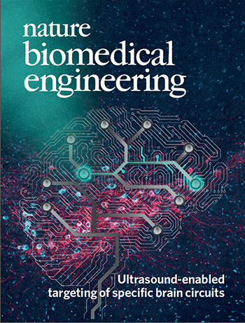
- Szablowski JO#, Bar-Zion A#, Shapiro MG, Achieving spatial and molecular specificity with ultrasound-targeted biomolecular therapeutics, Acc. Chem. Res. 52, 9, 2427-2434 (2019)
- Szablowski JO, Lue B, Lee-Gosselin A, Malounda D, Shapiro MG, Acoustically Targeted Chemogenetics for Noninvasive Control of Neural Circuits, Nature Biomedical Engineering, 2 (7), 475, (2018) [Cover article. Highlighted in News and Views, F1000 Prime]
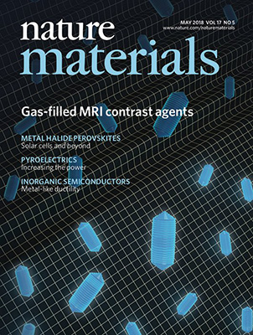
- Maresca D# , Lakshmanan A#, Abedi M, Bar-Zion A, Farhadi A, Lu GJ, Szablowski JO, Wu D, Yoo S, Shapiro MG, Biomolecular Ultrasound and Sonogenetics, Annu. Rev. Chem. Biomol. Eng, 9:229-252 (2018)
- Lu GJ, Farhadi A, Szablowski JO, Barnes SR, Lakshmanan A, Bourdeau RW, Shapiro MG, Acoustomagnetic imaging with gas-filled protein nanostructures, Nature materials 17 (5), 456 (2018) [Cover article. Highlighted in News and Views.]
- Piraner DI, Farhadi A, Davis HC, Wu D, Maresca D, Szablowski JO, Shapiro MG, Going Deeper: Biomolecular Tools for Acoustic and Magnetic Imaging and Control of Cellular Function, Biochemistry 56 (39), 5202-5209 (2018)
- Mysore VS, Szablowski JO, Dervan PB, Frost PJ. A DNA-binding Molecule Targeting the Adaptive Hypoxic Response in Multiple Myeloma has Potent Anti-tumor Activity. Mol Cancer Res. 14 (3), 253-266 (2016)
- Szablowski JO, Raskatov JA, Dervan PB. An HRE-binding Py-Im polyamide impairs hypoxic signaling in tumors. Mol. Cancer Ther. 15 (4), 608-617 (2016)
- Raskatov JA, Szablowski JO, Dervan PB, “Tumor Xenograft Uptake of a Py Im Polyamide Varies as a Function of Cell Line Grafted”, J. Med. Chem., 57:8471-8476 (2014)
- Yang F, Nickols NG, Li BC, Szablowski JO, Hamilton SR, Meier JL, Wang C, Dervan PB. "Animal Toxicity of Hairpin Pyrrole-Imidazole Polyamides Varies with the Turn Unit”, J. Med. Chem., 56:7449-7457, (2013).
- Nickols NG#, Szablowski JO#, Hargrove AE, Li BC, Raskatov JA, Dervan PB. "Activity of a Py-Im Polyamide Targeted to the Estrogen response Element," Mol. Cancer Ther., 12:675-684, (2013).
(Article selected as one of the ‘AACR hot topics, 2013’, available without subscription).
- Vilanova C, Hueso A, Palanca C, Marco G, Pitarch M, Otero E, Crespo J, Szablowski JO, Rivera S, Domínguez-Escribà L, Navarro E, Montagud A, Fernández de Córdoba P, González A, Ariño J, Moya A, Urchueguía J& Porcar M, "Aequorin-expressing yeast emits light under electric control",
J Biotechnology, 152(3):93-5, (2011)
- Shapiro MG#, Westmeyer GG#, Romero P, Szablowski JO, Küster B, Shah A, Otey CR, Langer R, Arnold FH, & Jasanoff AP, “Directed evolution of an MRI contrast agent for noninvasive imaging of dopamine”. Nature Biotechnology, 28:264–270 (2010)
- Shapiro MG, Szablowski JO, Langer R, Jasanoff AP, “Protein nanoparticles engineered to sense kinase activity in MRI”, JACS, 131(7):2484-2486, (2009)

GRANT SUPPORT
Total (approximate): >$10m total funding to the PI’s lab
17 funded grants (5x NIH, 2x DARPA, 1x ARIA, 9 private funders)
Current Research Support
- NIH NIDA, 1R21DA062242, Device-free, long-term monitoring of opioid circuit activity in individual mice exposed to morphine, 50% MPI (4/01/2025 - 3/31/2027, $215,188)
- NIH NIDA, Use of focused ultrasound stimulated blood brain barrier opening for CNS HIV/SIV reservoir reduction, Co-I, (07/01/2025-06/31/2030, $1,551,599 total)
- Bright Focus Foundation, Macular Degeneration Research award, Realtime monitoring of the expression of AMD risk genes TLE2 and FRZB in retinal pigment epithelium in vivo, PI, (07/01/2025-06/31/2028, $409,000)
- Advanced Research and Invention Agency (ARIA), Ultrasound-targeted On-demand Cell-autonomous Gene Therapy for Neurological Diseases, (02/01/2025-01/31/2028), Co-PI, £1,903,184 [~$2,574,513] for our work, includes $842k funds for CRO)
- Focused Ultrasound Foundation research grant, Development of viral vectors optimized for noninvasive, site-specific gene delivery to the brain, PI, (09/01/2024-02/28/2026, $128,899 total)
- Rice Synthetic Biology Institute (RSBI) seed funding. Recording gene expression history with a blood test, Co-PI, (05/11/2024-05/10/2025, $29,264 to PI)
- NIH Director’s New Innovator Award, DP2EB035905, Monitoring neuronal activity with a blood test - Released Markers of Activity (RMA), 09/01/2023-08/31/2028, 100% PI, ($2,347,500 total)
- NIH NEI, R21EY032596, Acoustically targeted, high-resolution, site-specific, transretinal delivery of macromolecules, 09-30-2022 –08-31-2025, Co-PI (50%)($434,598 total)
- NIH NIBIB Trailblazer Award, R21EB033059, Noninvasive site-specific measurement of gene expression in deep tissues with secreted reporters, , 09/13/2022-05/31/2025, (100% PI), ($585,920 total)
- Packard Fellowship, David and Lucile Packard Foundation ($875,000 total), 11/01/21-10/31/26
- The G. Harold & Leila Y. Mathers Foundation research grant, ID #MF-2012-01228, Noninvasive neuromodulation as a widely applicable therapy for brain disorders; (total direct cost: $418,520; 100% PI), 4/15/2021 - 6/30/2025

Completed Research Support (past three years)
- NARSAD Young Investigator grant, Acoustically Taregeted Chemogenetics, Brain and Behavior Research Foundation, (Total direct: $70,000), 01/2019-01/2021
- John S. Dunn Foundation Collaborative Research Award, Region-specific and Brain-wide Gene Therapy for Neurodevelopmental Disorders, (Total direct: $100,000, 50% PI), 09/01/2020 – 08/31/2022
- DARPA-SN-21-05-KEY-PA-006, DARPA BTO Keystone Study, LOI stage, High-speed biophysical and biochemical monitoring to discover early markers of unconventional brain injury, (Co-I with Luan (PI), Villapol, Robinson, Xie, Kemere; $421,177 to the PI)
- Welch Foundation Research Grant, Welch Foundation, Engineering a new class of site-specific therapeutics for brain disorders, (Total direct cost: $240,000; 100% PI), 06/01/2020-05/31/2023
- MJ Fox Foundation, MJFF-020154, Improved Outcome Measures, Development of PD biomarkers using focused ultrasound-based noninvasive biopsy, (2 years; $447,510, Contact PI; $327,123 to the PI), 08/01/2021-07/31/2023,
- DARPA-RA-21-03-01-YFA1-FP-003, Therapeutics for rapid cold adaptation - beyond the natural human capability, 11/1/2022 – 10/31/2025, 70% PI, $500,000 total
Pending (in review):
- NIH NEI, R01EY038474, Detection and noninvasive monitoring of early stage RGC gene expression changes in glaucoma, MPI (12/01/2025 - 11/30/2030, $1,003,115 to PI)
- NIH NINDS, R01NS146775, Acoustically-Guided Gene Therapies for Brain and Spinal Cord Pain Modulation, MPI, (12/01/2025 - 11/30/2030, $1,487,600 to PI)
- NIH NEI, R01EY036521, Noninvasive Approach for Monitoring Cellular States, Functionality, and Degeneration Within the Retina, (04/01/2025 - 03/31/2030, $3,970,666 total)
- CIRM, Novel Minimally Invasive Approach to Monitoring Gene and Cell Therapy in the Eye, Co-I, (10/01/2025 - 9/30/2028, $598,162 to PI)

Funding to trainees
PhD Students:
- NIH, NEI F30, Schuyler Link (2024-2026)
- NSF, GRFP, Manwal Harb (2021-2024)
- NSF, NRT, Nicolas Buitrago (2022-2023)
- NSF, NRT, Manwal Harb (2020-2021)
- NSF, GRFP, Emma Raisely (2024-2027)
Summer pre-Ph.D. students
- NSF, GRFP, Tsvetelina Baryakova (2021) (wrote the fellowship based on our lab’s work)
Postdoctoral
- Japanese Society for the Promotion of Science (JSPS) Postdoctoral Fellowship, Sho Watanabe (2024-2026)
Undergraduate
- Sigma Xi grant in aid, Ryan Wang (2023)
- DOD, NDSEG, Ryan Wang (2024)
- NSF, GRFP, Ryan Wang (2024)
SELECTED ORAL PRESENTATIONS
- Szablowski JO, Noninvasive Neuroengineering for in vivo interfacing with the living brain, Center for Neuroregeneration, Houston Methodist, Jan 27th, 2026
- Szablowski JO, Noninvasive Neuroengineering, The Epilepsy Exchange Meeting at the Texas Medical Center (EpiEx), January 8th, 2026
- Szablowski JO, Noninvasive Neuroengineering, ISBUS 2025, Caltech, Pasadena, CA, Dec. 2025 (upcoming), Keynote speaker
- Szablowski JO, Noninvasive Neuroengineering, Purdue University, Dept. of Biomedical Engineering, invited talk, October 14th (upcoming)
- Szablowski JO, Control and Monitoring of Intact Tissues with Noninvasive Neuroengineering, Bioorganic Chemistry GRC June 9-14th, 2025, invited talk
- Szablowski JO, Monitoring and Controlling the brain with noninvasive neuroengineering, Preclinical Imaging Conference (PIC), April 11th, 2025, invited plenary speaker
- Szablowski JO, Bioengineering Tools for Noninvasive Control and Monitoring of the Brain, American Academy of Neurology, April 9th, 2025, Invited plenary speaker
- Szablowski JO, Noninvasive Neuroengineering, Paris Sante campus, Institute of Medical Physics (France), March 21st, 2025, invited talk
- Szablowski JO, Synthetic Biology for Brain Disease Research, The Scientist magazine Webinar, March 6th, 2025, invited speaker
- Szablowski JO, Control and Monitoring of Intact Tissues with Noninvasive Neuroengineering, MIT Brain and Cognitive Sciences Neurotechnology Symposium, 11/20/2024, invited talk
- Szablowski JO, Control and Monitoring of Intact Tissues with Noninvasive Neuroengineering, Broad Institute of MIT and Harvard, 05/23/2024, invited talk
- Szablowski JO, Monitoring gene expression in the brain with synthetic serum markers, Acoustical Society of America, 05/13/2024, Ottawa, ON, invited talk
- Szablowski JO, Noninvasive monitoring of transgene expression in the brain, American Institute for Ultrasound in Medicine (AIUM), April 10th, 2024, Austin, TX, invited talk
- Szablowski JO, Control and Monitoring of Cells in Intact Tissues through Noninvasive Neuroengineering, Boston University, Neurophotonic Center and the Center for Systems Neuroscience, Boston, MA, April, 2024, invited talk
- Szablowski JO, Molecular Engineering in Gene Delivery with Focused Ultrasound, Focused Ultrasound Gene Therapy Symposium (November 16-17th, 2023, Washington DC), invited talk
- Szablowski JO, Control and Monitoring of Cells in Intact Tissues through Noninvasive Neuroengineering, Woodward Departmental Colloquium, Dept. of Chemistry and Chemical Biology, Harvard University, Boston, MA, November 2nd, 2023, invited talk
- Szablowski JO, Control and Monitoring of Intact tissues with Noninvasive Neuroengineering, University of Washington, Biological Structure Seminar series, Center of Excellence in Neurobiology of Addiction, Pain, and Emotion, October 13th 2023, invited talk
- Szablowski JO, Noninvasive Monitoring Brain Physiology, AAPM (July 23-27, 2023, Houston), invited talk
- Szablowski JO, Noninvasive Monitoring of Brain Physiology, SEED (2023, Los Angeles), June 2nd, invited plenary talk
- Szablowski JO, Noninvasive Neuroengineering, NeuroNano, SBMT (Feb 2023), invited talk
- Szablowski JO, Noninvasive Neuroengineering, UT Health Houston, Dept. of Neuroscience, Oct. 5th, 2022, invited talk
- Szablowski JO, Noninvasive Neuroengineering, D-CFAR Research Forum, October 10th, 2022, invited talk
- Szablowski JO, Noninvasive Neuroengineering, NeuroNano, Columbia University, 07/21/2022, invited talk
- Szablowski JO, Noninvasive Neuroengineering, VIB Neurotechnologies (KU Leuven, Belgium), 28/09/2022, invited talk
- Szablowski JO, Neuroengineering, Brain Bee 2021, educational talk for high school students (03/2021).
- Jerzy Szablowski, Audrey Lee-Gosselin, Brian Lue, Dina Malounda, Mikhail Shapiro, Acoustically Targeted Chemogenetics for a Noninvasive Spatially, Temporally, and Cell-specific Control of Neural Circuits., BMES 2018 Annual Meeting, 10/19/2018, oral presentation,
- Szablowski JO, Noninvasive Gene Therapy for Brain Disorders - Acoustically Targeted Chemogenetics, University of Utah, Imaging Elevated Symposium, 10/16/2018, award symposium talk
- Szablowski JO, Acoustically Targeted Chemogenetics for noninvasive neuromodulation, at “Methods and applications of ultrasound in molecular imaging and drug delivery” workshop at WMIC 2018, 09/12/2018, educational talk
- Szablowski JO, Lue B, Lee-Gosselin A, Malounda D, Shapiro MG, Acoustically Targeted Chemogenetics for noninvasive control of neural circuits, International Society of Therapeutic Ultrasound Annual Meeting, 05/15/2018
- Szablowski JO, Acoustically Targeted Chemogenetics, “Neurolunch” Seminar Series, 12/12/2017
- Szablowski JO, An HRE-binding Py-Im Polyamide Impairs Adaptation of Tumors to Hypoxia, 04/02/2015, Center for the Chemistry of Cellular Signaling Seminar
- Szablowski JO, Bioengineering and Biological Engineering, 23.09.2010, 14th Science Festival in Warsaw, educational talk for general audience
- Szablowski JO, Protein Engineering or how to make your own enzymes, 23.09.2010, 14th Science Festival in Warsaw, educational talk for general audience

SELECTED POSTER PRESENTATIONS
- Szablowski JO, London ZN, Controlling the Brain with Acoustically-Delivered Molecules, NeuroBytes, American Academy of Neurology course, March 7th, 2025
- Szablowski JO, Li R, Heath J, Shapiro M, P370.05: A viral vector engineered for improved spatially-specific noninvasive gene delivery to the brain., SFN Global Connectome (01/11/2021)
- Szablowski JO, Li R, Heath J, Shapiro M, A viral vector engineered for improved focused ultrasound BBB opening gene delivery., FUS Foundation annual meeting (11/2020)
- Szablowski JO, Lue B, Lee-Gosselin A, Malounda D, Shapiro MG, Acoustically Targeted Chemogenetics for noninvasive neuromodulation, WMIC 2018, 09/15/2018

PATENTS
- Szablowski JO, Buitrago NS, Mechanism Agnostic Directed Evolution of Protein Therapeutics, Rice Tech ID 2023-044-US
- Szablowski JO, Huang Z, Site Specific Brain Therapeutics, Rice Tech ID 2023-066-PZ
- Szablowski JO, Seo JP, "Noninvasive Site-Specific Measurement of Transgene Expression in the Brain", Rice Tech ID: 2023-067
- Szablowski JO, Lee S, Noninvasive monitoring of gene expression in the brain using synthetic serum markers, Rice Tech ID 2022-069, 05/30/2022
- Szablowski JO, Li H, Heath JE, Shapiro MG, Viral Vectors Engineered for Enhanced Ultrasound-Mediated Delivery to the Brain, Serial Number: 63/225,006, Filed: 7/23/2021, CIT File Number: 8680-P
- Szablowski JO, Shapiro MG, Methods And Systems For Noninvasive Control Of Brain Cells And Related Vectors And Compositions, Serial Number: 16/213,991, Filed: 12/7/2018, CIT File Number: 7921
- Lu G, Farhadi A, Szablowski JO, Shapiro MG, Gas Filled Structures and related compositions, methods and systems for magnetic resonance imaging, CIT File No.: CIT-7580-P, Provisional filed: 7/28/2016, Patent application filed: 7/28/2017
- Szablowski JO, User-adjustable knee orthosis for patellar instability and related disorders, CIT File No.: CIT 12-216, Provisional Filed: 8/7/2012
STUDENTS SUPERVISED
Postdoctoral
Name | Year(s) Supervised | Record of Placement
Zhimin Huang | 2020-2024 | Assistant Professor, University of Pittsburgh, Neurosurgery
Sho Watanabe | 2023-current | Current, Japan Society for the Promotion of Science (JSPS) Fellow
Graduate
Current Graduate Students | Degree Sought
Xia Boao | Ph.D. Bioengineering
Nouraein Shirin | Ph.D. Systems, Synthetic, and Physical Biology
Link Schuyler | Ph.D. Bioengineering
Buitrago Nicolas | Ph.D. Systems, Synthetic, and Physical Biology
Wen Ruoxin | Ph.D. Systems, Synthetic, and Physical Biology
Isaac Ive | Ph.D. Systems, Synthetic, and Physical Biology
Honghao Li | Ph.D. Bioengineering
Emma Raisley | Ph.D. Bioengineering
Selin Aras | MBE Bioengineering
Mihika Ramprasad | MBE Bioengineering
Graduate Alumni
Year | Name | Degree(s) Conferred | Record of Placement
2025 | Manwal Harb | Ph.D. (Defense: 05/01/2025)  Bioengineering | CEO, stealth ultrasound company, UTSW spin off (from 08/2025)
2025 | Joon Pyung Seo | Ph.D. (Defense: 04/23/2025)  Applied Physics | TBD
2024 | Sangsin Lee | Ph.D.  Bioengineering | Stanford University, Alice Ting lab, Wu Tsai institute interdisciplinary fellowship

2025 | Josefina Brau | MBE  Bioengineering | Applied Data Engineer, CellChorus
2025 | Zigang Wu | MBE  Bioengineering | Szablowski lab, Rice University, Research technician
2024 | Rongshu Jin | MBE  Bioengineering | Rice University, Bioengineering, Ph.D.
2024 | Diana Dutava | MBE  Computer Science | N/A
2022 | James S. Trippett | MBE  Bioengineering | McGovern School of Medicine
2022 | James Kwon | MBE  Bioengineering | Texas A&M School of Medicine
2022 | Visnhu Rangachari | MBE  Bioengineering | N/A
2021 | Kevin Gonzalez | MBE  Bioengineering | Adjunct Professor, Tecnologico de Monterrey
2021 | Huckie Del Mundo | MBE  Bioengineering | Spanios (https://spanioslab.com/)

Undergraduate
Name | Year(s) Supervised | Outcomes
Joycelin Yiu | 2020-2021 | Ph.D. Bioengineering, UCSD
Ryan Wang | 2021-2024 | Ph.D.,Bioengineering, Stanford University
Oriana Tang | 2022-2024 | Rice University
Vidal Saenz | 2022-2024 | Rice University
Aurian Maleki | 2020-2020 | Rice University
Andrei Mitrofan | 2020-2022 | 8fold mfg, PicoPump Inc, co-founder
Richard Gao | 2022-2022 | Rice University
Mina Ghayour | 2021-2021 | Rice University
Priyanka Patel | 2023-2023 | Rice University
Olivia Kemper | 2023-2023 | Rice University
Paula Gonzalez | 2022-2022 | Wellesley College
Clark Horak | 2023-2023 | University of Houston
Yuna Choi | 2022-2023 | Rice University
Helena Song | 2024-current | Rice University
Akshara Sankar | 2023-current | Rice University
Jesus Adame | 2024-current | Rice University
Kara Fan | 2024-current | Rice University
Eesha Kodavatikanti | 2025-current | Rice University
Sophia Jeffrey | 2025-current | Rice University

Technical staff
Name | Year(s) Supervised | Outcomes
Yerim Park | 2023-current | Rice University
Zigang Wu | 2025-current | Rice University
Zachary Lane | 2022-2023 | Postdoc, Whitney Lab for Marine Biology, Schnitzler Lab
Shirin Nouraein | 2021-2022 | PhD, Rice SSPB
Darrion Nguyen | 2022-2022 | Ryan’s World, presenter (~35m subscriber educational Youtube channel)
James S. Trippett | 2022-2023 | McGovern School of Medicine
Cooper Lueck | 2021-2022 | Texas A&M School of Medicine, ENMED program

Ph.D. Defense committees
Bonu Vohidova (BioE)
Hannah Lim (BioE)
Jon Montes (BioE)
Anton Banta (ECE)
Dhiraj Jain (SSPB)
Fatima Ahsan (ECE)
Jiawei Lu (BioE)
Nicole Sevilla (BioE)
Boqiang Fan (ECE)
Ben Kaufman (BioE)

SERVICE
Rice University
2025-current Faculty search committee, Rice University Dept. of Bioengineering
2025-current Collective Excellence Committee
2024-2025 Graduate students admissions committee, Rice University Dept. of Bioengineering
2022-current Rice Future Leaders in Bioengineering, seminar series for postdoctoral fellows and graduate students (co-founder; organizing committee)
2022-current Rice Neuroengineering Initiative annual meeting, organizing committee
2022-2023 Faculty search committee, Dept. of Bioengineering
2020-current Professional Masters Affairs Committee, Rice University Dept. of Bioengineering
2020-2022 Industry and Alumni Relations Committee, Rice University Dept. of Bioengineering
2020-2023 IACUC, standing member
2020-2024 DEI Committee, standing member, Rice University Dept. of Bioengineering
2020 Graduate admissions committee, Rice University Dept. of Bioengineering
2021-current Graduate admissions committee, Systems, Synthetic, and Physical Biology program
2020 Rice Bioengineering Covid-19 task force (co-founder)

External Service
Baylor College of Medicine
20250-current: MSTP Faculty Operating Committee (MD/Ph.D. program BCM/Rice Bioengineering)

Grant reviews:
NIH 7 panels; BRAIN initiative, NINDS, NIMH, SBIR:
2020: ZMH1 ERB-M (08),
2021: ERB-M(07)
2022: ZMH1 ERB-M (02)
2023: ZNS1 SRB-O (22), ZRG1 NV-Q (91) S
2024: ZMH1 ERB-M (01); ZRG1 NV-H (13)
2025: ZRG1 NV-J (50)

John S. Dunn foundation
Israel Science Foundation (ISF)
Chan-Zucker Berg Initiative (CZI)
Human Frontiers Science Foundation (HFSP)
National Science Foundation (NSF)
Children’s Cancer and Leukaemia Group
Focused Ultrasound Foundation

Paper reviews
Science Translational Medicine
Cancer Research
PNAS
Neuron
Nature Biomedical Engineering
Nature Biotechnology
Nature communications
Molecular Therapy: Nucleic Acids
Transactions in Biomedical Engineering
Nature Reviews Chemistry
Theranostics
iScience

Abstract reviews:
Biomedical Engineering Society (BMES)
World Molecular Imaging Congress (WMIC)

Organizing committees
2020-2021 11th International Conference for Biomolecular Engineering (organizing committee) (Virtual due to the Covid-19 pandemic)
2022-2023 SEED 2023 (organizing committee, Los Angeles, CA

Memberships
2018-present Biomedical Engineering Society (BMES)
2016-present World Molecular Imaging Society (WMIS)
2018, 2020 Society for Neuroscience (SfN)
2024-present American Institute of Chemical Engineers (AiChE)
2024-present International Society for Therapeutic Ultrasound (ISTU)
2024-present American Chemical Society (ACS)

